Day- 5
Case Study Practical
1.A user reports their laptop won't power on even when plugged in. List 5 troubleshooting steps you would take to diagnose the cause, and for each step, explain what you are checking for.
Troubleshooting a Laptop That Won't Power On
Scenario
A user reports that their laptop does not turn on, even when connected to the charger. The problem could be caused by a faulty charger, damaged charging port, battery failure, or internal hardware issue.
The following five troubleshooting steps can help identify the cause.
1. Check the Power Adapter and Charging Cable
What to check:
- Ensure the charger is properly connected to the laptop and wall socket.
- Check whether the charging cable is damaged or loose.
- Try another compatible power adapter if available.
Reason: A faulty charger may not supply sufficient power to the laptop, preventing it from turning on.
2. Check the Charging Indicator Light
What to check:
- Connect the charger and observe the laptop's charging LED.
- Check whether the light turns on, blinks, or remains off.
Reason: If the charging light does not turn on, it may indicate a faulty charger, charging port, battery, or internal power circuit.
3. Perform a Hard Reset (Power Reset)
Steps:
- Disconnect the charger.
- Remove the battery if it is removable.
- Press and hold the power button for 15–30 seconds.
- Reconnect the charger and try turning on the laptop.
Reason: This helps discharge residual electrical power and can resolve temporary power-related issues.
4. Check the Battery and Charging Port
What to check:
- Inspect the charging port for physical damage or loose connections.
- Check whether the battery is swollen or damaged.
- If the battery is removable, try starting the laptop using the charger without the battery, if supported.
Reason: A faulty battery or damaged charging port may prevent the laptop from receiving or maintaining power.
5. Check Internal Hardware
What to check:
- Inspect the motherboard and internal power connections.
- Check for damaged components or signs of liquid damage.
- If possible, test with a known-working compatible charger and battery.
Reason: If the charger, battery, and charging port are working correctly, the problem may be caused by a faulty motherboard or internal power circuit.
Summary Table
Step | Component Checked | Possible Problem
1 | Power adapter and cable | Faulty charger or damaged cable
2 | Charging indicator | Power supply or charging circuit issue
3 | Power system | Temporary electrical issue
4 | Battery and charging port | Battery failure or damaged port
5 | Internal hardware | Motherboard or power circuit failure
Conclusion
A laptop that does not power on even when plugged in may have a problem with its charger, battery, charging port, or motherboard. By following these five troubleshooting steps systematically, a technician can identify the possible cause and decide whether a component needs repair or replacement.
2.You receive a helpdesk ticket: 'My monitor is showing a blank screen, but the CPU seems to be running.' Write a step-by-step troubleshooting flow you would follow to identify and resolve the issue.<br><br><em><strong>Hint:</strong> Consider checking both hardware connections and basic display settings.</em>
2. Troubleshooting a Monitor Showing a Blank Screen
Scenario
A user reports that the monitor displays a blank screen, but the computer (CPU/system unit) appears to be running. This problem may be caused by loose display cables, incorrect monitor input settings, a faulty monitor, or a graphics card issue.
The following step-by-step troubleshooting process can help identify and resolve the problem.
Step 1: Check Monitor Power
What to check:
- Ensure the monitor is switched on.
- Check whether the power cable is properly connected.
- Verify that the monitor's power indicator light is on.
Reason: A loose power cable or switched-off monitor can cause a blank screen.
Step 2: Check Display Cable Connections
What to check:
- Inspect the HDMI, VGA, or DisplayPort cable.
- Ensure both ends are securely connected to the monitor and computer.
- Try another cable if the existing cable is damaged.
Reason: A loose or faulty display cable can prevent the monitor from receiving video signals.
Step 3: Check the Monitor Input Source
What to check:
- Open the monitor's menu using its physical buttons.
- Select the correct input source, such as HDMI, VGA, or DisplayPort.
Reason: If the monitor is set to the wrong input source, it may display a blank screen even when the computer is running.
Step 4: Check the Graphics Card
What to check:
- Ensure the graphics card is properly seated in the motherboard's PCIe slot.
- Check that its required power connectors are attached.
- If possible, test another display output.
Reason: A loose or faulty GPU may prevent the computer from sending video signals to the monitor.
Step 5: Check Display Settings
What to check:
- Press Windows + P to open display projection options.
- Select PC screen only or Duplicate.
- Check whether the display resolution and refresh rate are supported by the monitor.
Reason: Incorrect display settings or an unsupported resolution can cause display problems.
Step 6: Test with Another Monitor
What to check:
- Connect the computer to another working monitor or TV.
- Alternatively, connect the original monitor to another computer.
Reason: This helps determine whether the issue is caused by the monitor or the computer's graphics hardware.

Troubleshooting Flowchart
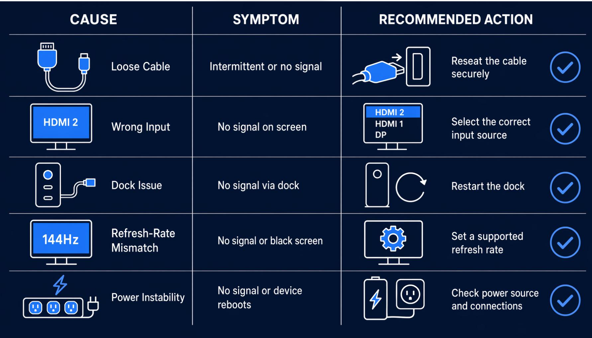
Summary Table
Step | Component Checked | Possible Issue
1 | Monitor power | Power cable or power supply issue
2 | Display cable | Loose or damaged HDMI/VGA cable
3 | Input source | Incorrect monitor input selection
4 | Graphics card | Loose or faulty GPU
5 | Display settings | Incorrect resolution or display mode
6 | Another monitor | Faulty monitor or computer hardware

Conclusion
A blank monitor screen does not always mean that the computer has failed. It may be caused by a power connection, faulty display cable, incorrect input source, graphics card problem, or display configuration. By checking these components step by step and testing with another monitor, a technician can identify the cause and resolve the issue.

3.A user complains that their wireless mouse is unresponsive, but the keyboard works fine. Describe how you would isolate whether the issue is with the mouse, the USB port, or the system settings.
Troubleshooting an Unresponsive Wireless Mouse
Scenario
A user reports that their wireless mouse is not responding, but the keyboard is working properly. This may be caused by a low battery, faulty USB receiver, damaged USB port, wireless connection problem, or incorrect system settings.
To identify the cause, I would follow these troubleshooting steps.
Step 1: Check the Mouse Battery and Power
What to check:
- Ensure the mouse is switched ON.
- Check whether the battery is low or completely discharged.
- Replace the battery or recharge the mouse if necessary.
Reason: A wireless mouse needs sufficient power to communicate with the computer.
Step 2: Check the USB Receiver
What to check:
- Ensure the wireless USB receiver (dongle) is properly connected.
- Remove and reconnect the receiver.
- Check whether the mouse responds.
Reason: A loose or faulty USB receiver can interrupt communication between the mouse and computer.
Step 3: Test Another USB Port
What to check:
- Connect the receiver to another USB port.
- Check whether the mouse starts working.
Reason: The original USB port may be damaged or not functioning correctly.
Step 4: Check System Settings and Drivers
What to check:
- Open Device Manager in Windows.
- Expand the Mice and other pointing devices section.
- Check whether the wireless mouse is detected.
- Look for driver errors and update or reinstall the driver if required.
Reason: Incorrect settings, disabled devices, or corrupted drivers can prevent the mouse from working properly.
Step 5: Test the Mouse on Another Computer
What to check:
- Connect the wireless receiver to another working computer.
- Check whether the mouse responds.
- If possible, test another wireless mouse on the original computer.
Reason: This helps identify whether the problem is with the mouse itself or the original computer.

Summary Table
Step | Component Checked | Possible Issue
1 | Mouse battery | Low or discharged battery
2 | USB receiver | Loose or faulty receiver
3 | USB port | Damaged or non-working port
4 | System settings | Driver or device configuration issue
5 | Mouse on another PC | Faulty mouse or receiver
Conclusion
An unresponsive wireless mouse may be caused by battery problems, a faulty USB receiver, a damaged USB port, or incorrect system settings. By checking the battery, testing different USB ports, verifying drivers, and connecting the mouse to another computer, a technician can isolate the cause and determine the appropriate solution.
4.Imagine you are working on a helpdesk team for a gaming cafe. One system is overheating and shutting down during use. List 3 possible hardware causes and describe how you would check each one.<br><br><em><strong>Hint:</strong> Think about fans, dust, and thermal paste.</em>
Troubleshooting an Overheating Gaming PC
Scenario
A gaming cafe user reports that one computer becomes extremely hot and shuts down automatically while playing games.
This problem may occur because the cooling system is not working properly. Three common hardware causes are faulty cooling fans, dust accumulation, and dried-out thermal paste.
1. Faulty or Non-Working Cooling Fans
Possible cause:
The CPU or GPU cooling fans may stop working or rotate slowly due to damage or loose connections.
How I would check:
- Open the computer case after switching off and disconnecting the power.
- Check whether the CPU and GPU fans are physically damaged.
- Check whether the fans spin properly when the system is running.
- Inspect the fan power connections.
Solution: Replace faulty fans or reconnect loose fan cables.
2. Dust Accumulation in the Cooling System
Possible cause:
Dust can accumulate on fans, heatsinks and air vents, blocking airflow and preventing proper heat dissipation.
How I would check:
- Inspect the CPU cooler, GPU fans and air vents.
- Look for dust blocking the heatsink fins.
- Check whether the airflow inside the cabinet is restricted.
Solution: Clean the fans, heatsinks and air vents using compressed air or an appropriate cleaning tool.
3. Dried or Improperly Applied Thermal Paste
Possible cause:
Thermal paste transfers heat from the CPU to the heatsink. If it becomes dry or is applied incorrectly, heat transfer becomes less effective.
How I would check:
- Inspect the CPU cooler installation.
- If necessary, remove the cooler carefully.
- Check whether the thermal paste is dried out or unevenly applied.
Solution: Clean the old thermal paste using appropriate cleaning materials and apply a fresh, suitable layer before reinstalling the cooler.

Summary Table
Hardware Cause | How to Check | Solution
Faulty cooling fans | Check fan rotation and connections. | Repair or replace fans.
Dust accumulation | Inspect fans, heatsinks and air vents. | Clean dust and improve airflow.
Dried thermal paste | Inspect the CPU cooler and thermal paste condition. | Apply fresh thermal paste.
Conclusion
Overheating in a gaming PC can be caused by faulty fans, dust accumulation, or dried thermal paste. By inspecting the cooling system, checking fan operation and maintaining proper heat transfer, a technician can reduce overheating and prevent unexpected shutdowns.
Real-world example: If a gaming PC shuts down after 20–30 minutes of playing a graphics-intensive game, a blocked GPU heatsink or faulty cooling fan could be responsible.
Practical safety tip: Never touch moving fans or internal components while the PC is powered on. Allow the system to cool before inspecting it.

